Record No: 0596
ELIZA BELLINGHAM SOMERVILLE (Aunt Nelson)

2nd daughter of William Somerville (0563) and Elizabeth Bellingham (0564).

Birth: 13 Sept 1813 at Dundalk.
Marriage: 15 Apr 1833 at Newtonbutler, Co Fermanagh, to Thomas Nelson (0597)
Death: 21 Oct 1879 St Louis, USA.

Notes:
SR3015: Letter from her husband makes reference to her death.
Had issue.

Source: Somerville Index.

Aunt Nelson, being the only surviving daughter, and a good correspondent, supplies great information.
She was evidently very close to her mother who clearly confided in her. Her reaction to the possibility of a union between AJS and Bessie was exactly that of her mother. Both of them found the Crawford family a ‘curious odd family’ in Eliza Bellingham’s words; ‘nothing but hermits’ in Aunt Nelson’s. Everything Aunt Nelson says in her correspondence to her brother, many years after the birth of Little Archie and the Bessie/AJS affair, is corroborated by Capt William’s Diary, Tenison Alan’s Declaration and Corry’s correspondence many years later. Cecilia Eliza clearly didn’t believe Aunt Nelson about AJS’ two marriages, but nothing that Aunt Nelson has said has been disproved.

The surviving correspondence of Aunt Nelson is voluminous; and, quite apart from the AJS affairs, interesting reading.

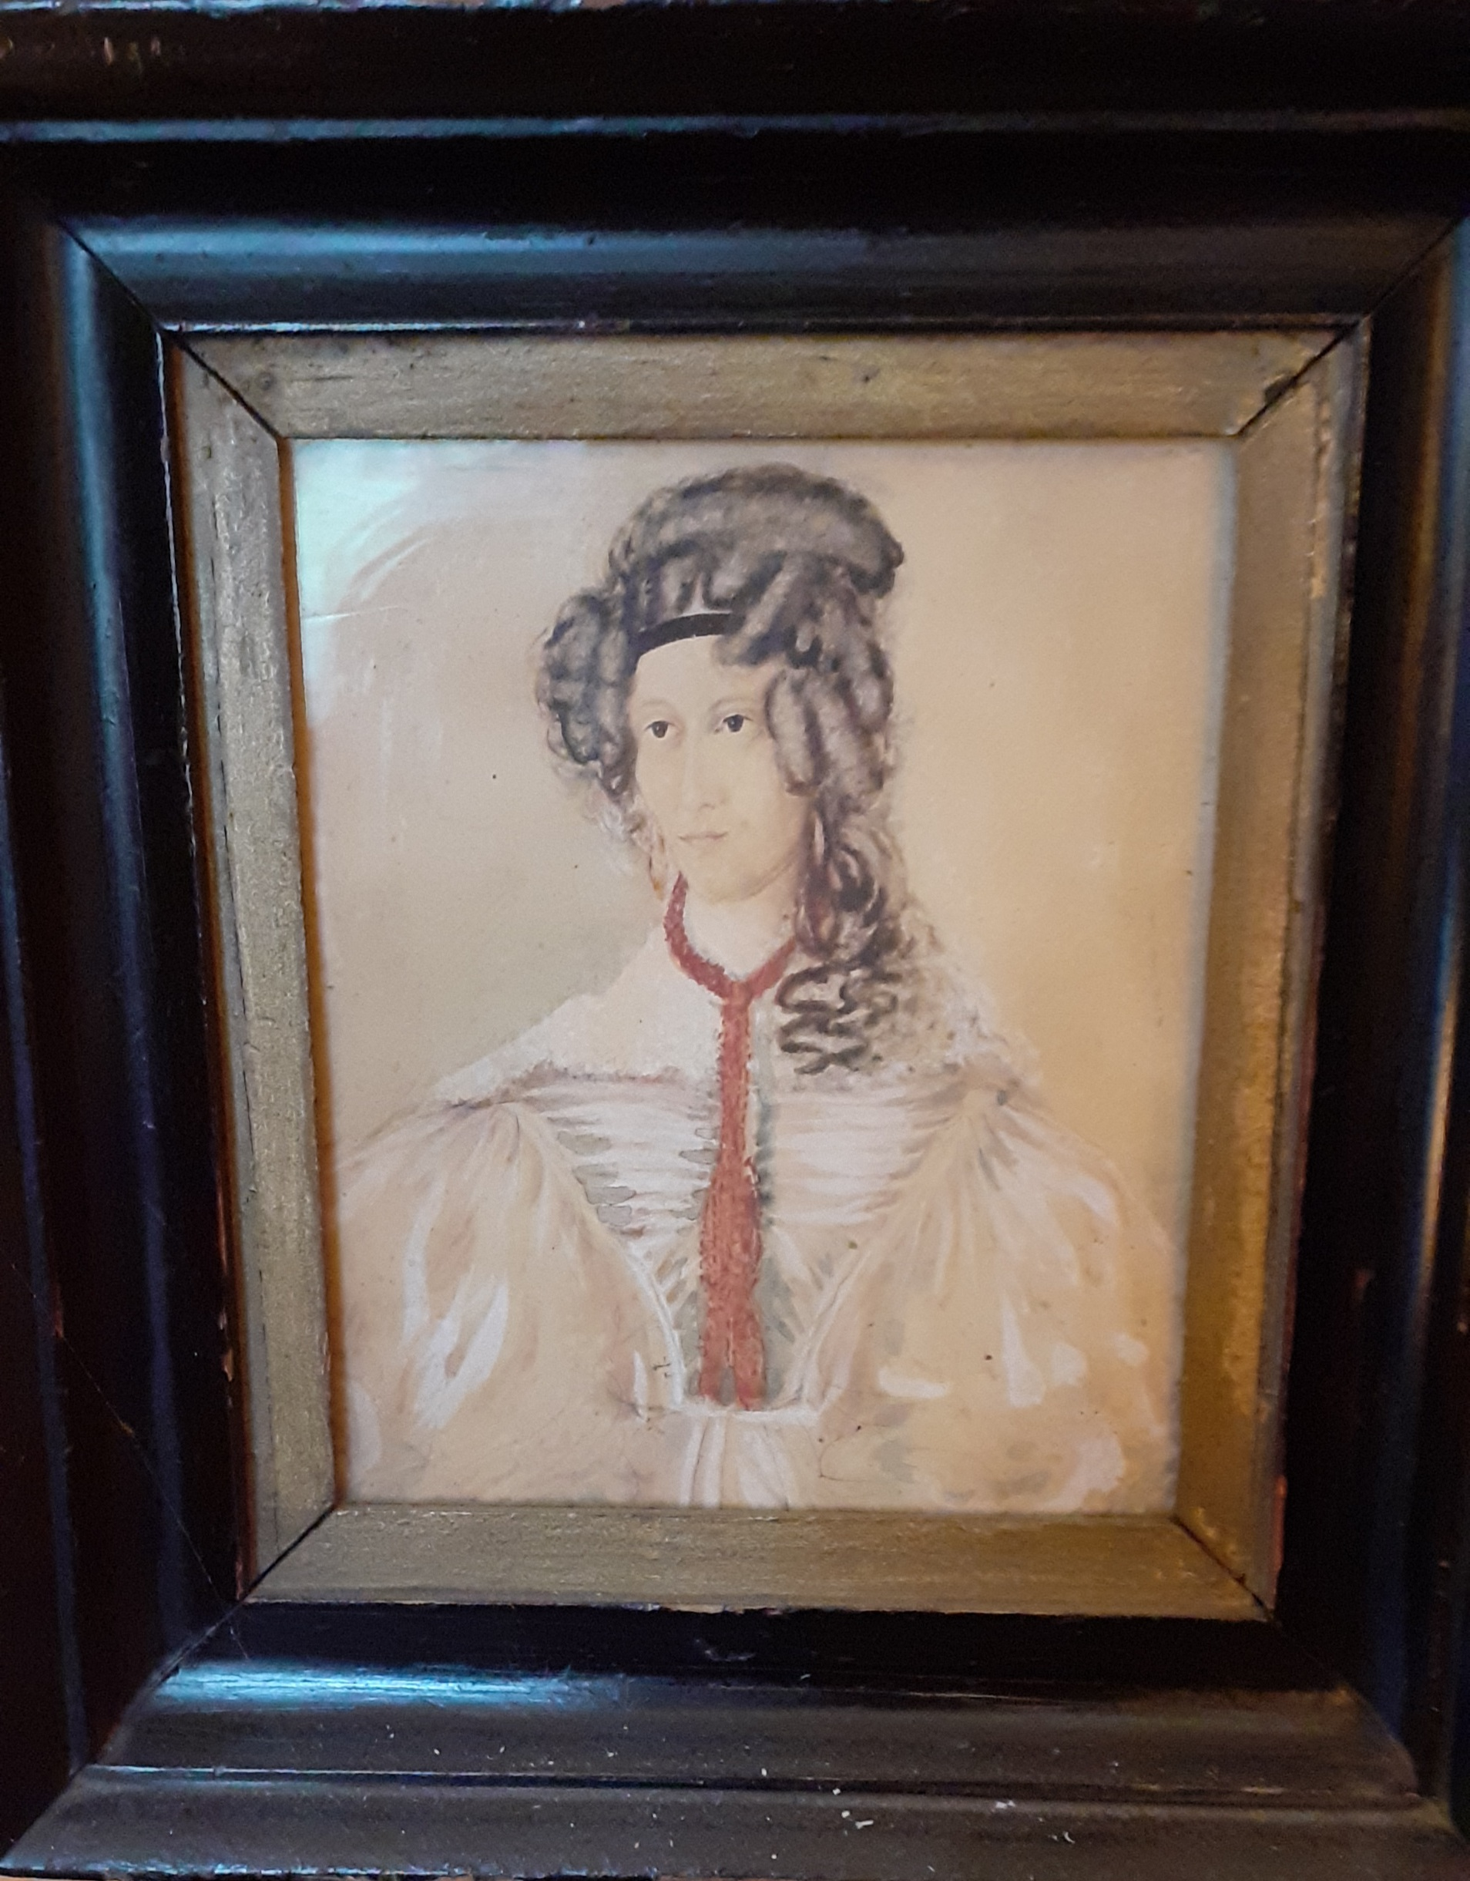

Aunt Nelson, daughter of Capt William Somerville and Eliza (nee Bellingham) who married Thomas Nelson ((1813-1879)

